**DAILY ONLINE ACTIVITIES SUMMARY**

|  |  |  |  |  |  |  |  |  |
| --- | --- | --- | --- | --- | --- | --- | --- | --- |
| Date: | 09/06/2020 | | | | | Name: | Jyothi B R | |
| Sem & Sec | IV-A | | | | | USN: | 4AL18CS030 | |
| Online Test Summary | | | | | | | | |
| Subject | | --- | | | | | | |
| Max. Marks | | -- | | Score | | | -- | |
| Certification Course Summary | | | | | | | | |
| Course | Programming Essentials in Python | | | | | | | |
| Certificate Provider | | | Cisco Virtual Academy | | Duration | | | 3hrs |
| Coding Challenges | | | | | | | | |
| |  |  |  | | --- | --- | --- | | |  | | --- | | Problem Statement:  Write a Java Program to check whether the given matrix is magic square or not | |  | | | | | | | | | |
| Status:Completed | | | | | | | | |
| Uploaded the report in Github | | | | | Yes | | | |
| If yes Repository name | | | | | https://github.com/alvas-education-foundation/jyothi_b_r | | | |
| Uploaded the report in slack | | | | | Yes | | | |

Online Test Details: (Attach the snapshot and briefly write the report for the same)

Certification Course Details: (Attach the snapshot and briefly write the report for the same)

Coding Challenges Details: (Attach the snapshot and briefly write the report for the same)

**ONLINE TEST DETAILS :**NOT CONDUCTED

CERTIFICATION COURSE DETAILS:

Programming Essentials in Python :

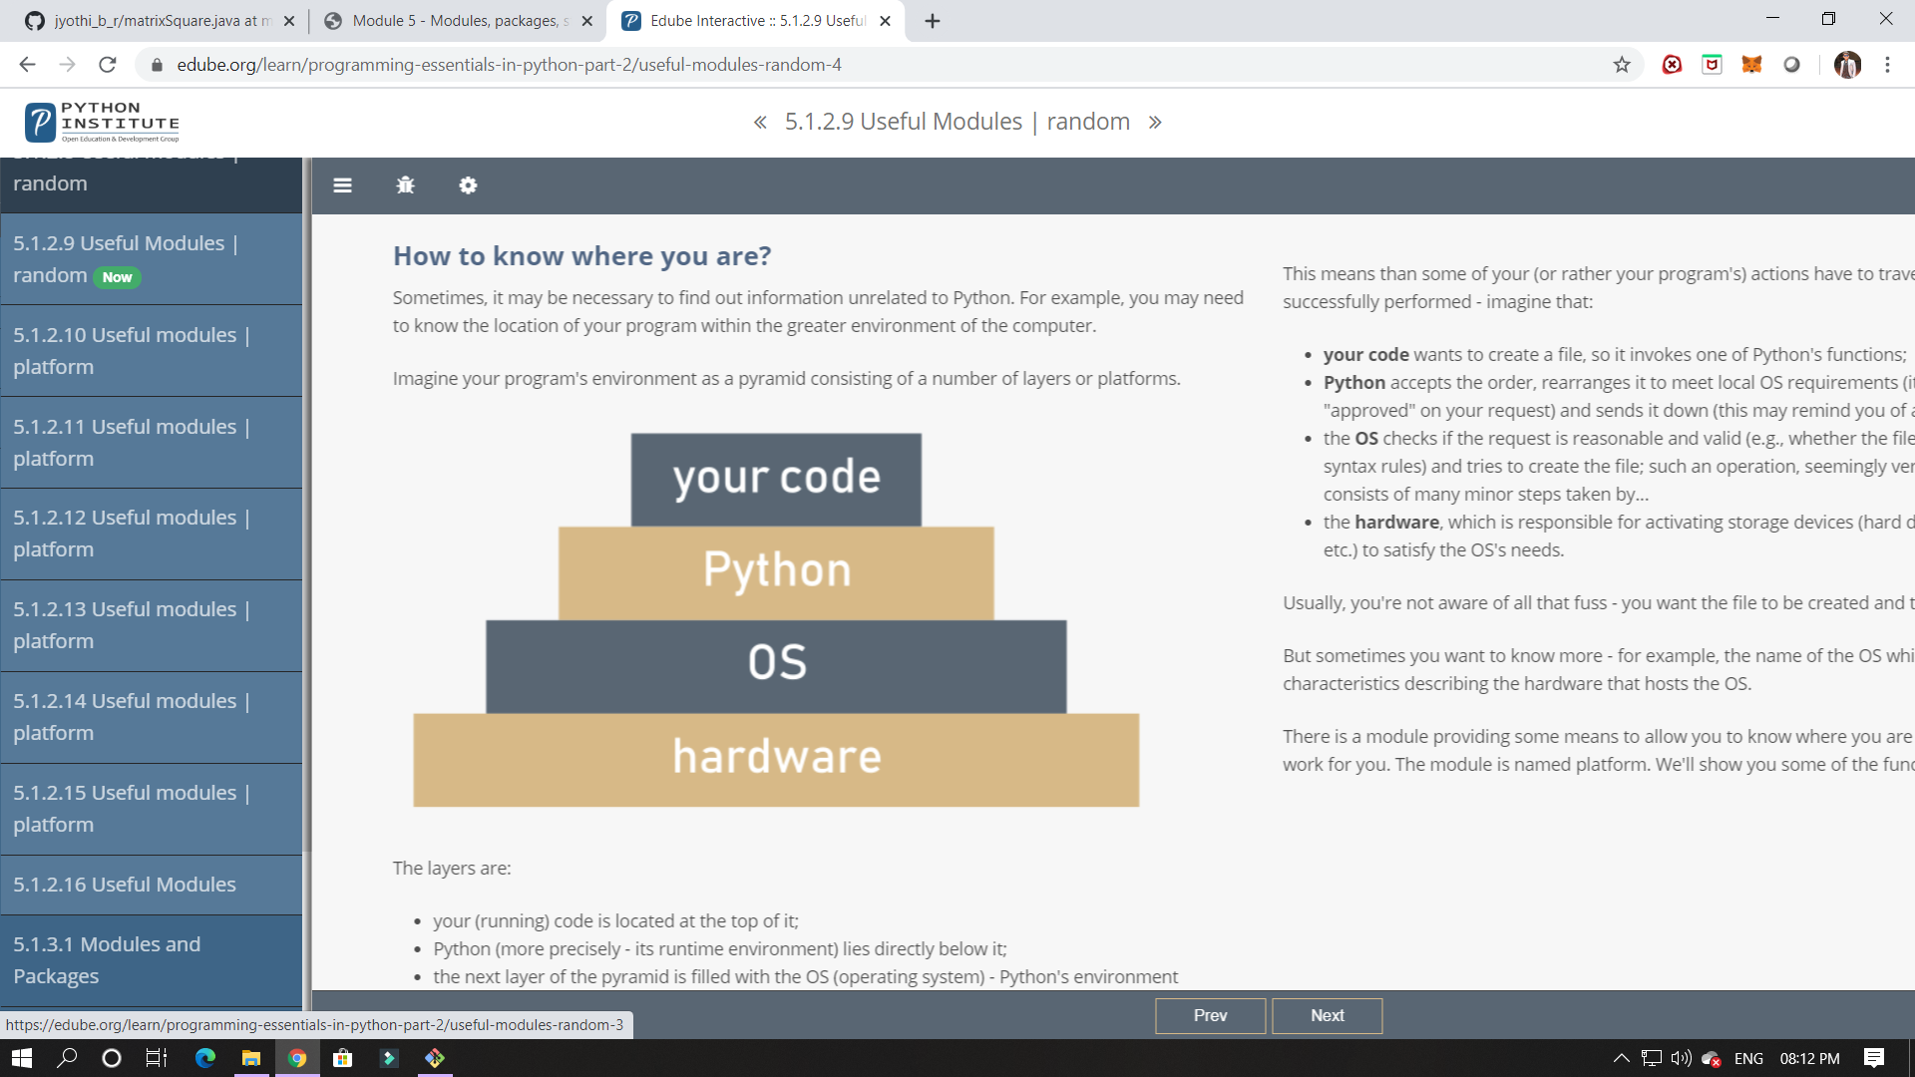

In this module its shows about modules, packages, string and its methods,and exceptions.

In this module I have studied about modules and how it can be implemented and importing the functions in it.

ONLINE CODING:

Given a matrix, check whether it’s Magic Square or not. A Magic Square is a n x n matrix of distinct element from 1 to n2 where sum of any row, column or diagonal is always equal to same number.

Examples:

Input : n = 3  
2 7 6  
9 5 1  
4 3 8  
Output : Magic matrix

